📝 Notes
May 7, 2026

Contained Animal Management System | Design Review 3
Invited Christian Ruiz Francisco Perez Tyler Morton Raul Montenegro Claudiu Constantin wyldsolconsulting@gmail.com
Attachments Contained Animal Management System | Design Review 3
Meeting records Transcript Recording

Summary
Design review session finalized Minimum Viable Product dashboard refinements and established future development procedures.
Onboarding and Dashboard Design
Designers refined subscription tier displays and dashboard aesthetics using earthy tones. A decision was made to restrict editing basic animal statuses to prevent technical issues.
Event and Inventory Management
The team simplified event listings into an aggregated view with sticky date columns for mobile. Bulk animal actions were updated to include multi-select location changes.
Partnership and Future Procedures
Role semantics were adjusted to explore handler definitions for competition accuracy. Future design updates will transition to asynchronous reviews via Basecamp.

Rate this Summary: Helpful or Not Helpful

Decisions
We've updated the Decisions section using your feedback.
Let us know what you think: Helpful or Not Helpful

NEEDS FURTHER DISCUSSION
- Partner and owner role terminology The team is considering whether to rename 'Bull Owner' roles to 'Handler' and needs to determine the appropriate terminology.
- Animal type removal capabilities The team requires stakeholder input to determine if basic animal types can be customized or removed by users.

ALIGNED
- Yearly subscription billing cycle chosen The subscription billing model is set to yearly with no option for users to change to monthly billing for the MVP.
- Introductory onboarding tour included An introductory onboarding tour for new users will be included in the MVP design.
- Invoicing features excluded from MVP Invoicing features are excluded from the MVP dashboard and recent activity views.
- Earthy UI color palette adopted The UI color scheme is set to utilize earthy tones, such as green, brown, and yellow, replacing the previous pink and blue.
- Sticky date column for tables The event list table view will utilize a sticky date column to maintain context during side-scrolling.
- Unique Ranch ID implementation A unique Ranch ID will be implemented to facilitate connections between partners and ranch data.
- Locked basic animal statuses Basic system animal statuses are restricted and cannot be removed by users to ensure system integrity.
- Media sharing functionality addition A media sharing feature allowing users to select pictures and send them to contacts will be added to the media page.

Next steps
- [Claudiu Constantin] Update Payment: Modify subscription screen to display yearly payment logic.
- [WyldSol] Review Bulk Actions: Verify the current list of proposed bulk actions for inventory multi selection.
- [WyldSol] Post Event API: Share the event platform API information at the beginning of the year.
- [WyldSol] Confirm Animal Types: Consult stakeholders regarding basic required animal type statuses that cannot be removed.
- [Claudiu Constantin] Add Ranch ID: Incorporate a ranch ID preview into the design screens.
- [Claudiu Constantin] Resolve Design Comments: Review all existing design comments and ensure they have been addressed.
- [WyldSol] Review Design Language: Go over the design file language to ensure proper terminology is used.
- [Claudiu Constantin] Complete Main Flows: Design the remaining flows for adding an animal and adding media for mobile and desktop views by Monday end of day.
- [Claudiu Constantin] Design Animal Comments: Add comments mockup to the final animal profile design flow.

Details
Did the screenshots in this section make your notes better or worse?
- Onboarding Flow and Subscription Plans: The onboarding process is structured into three steps: selecting a subscription plan, providing operation data, and optionally importing inventory (00:00:00). To address space constraints, the subscription plans are displayed in two tabs for "owner" and "partner" tiers (00:01:26). They also decided to display the monthly payment amount but noted that the payment is actually billed yearly, and Claudiu Constantin will need to update the design to reflect the yearly payment logic (00:03:04).
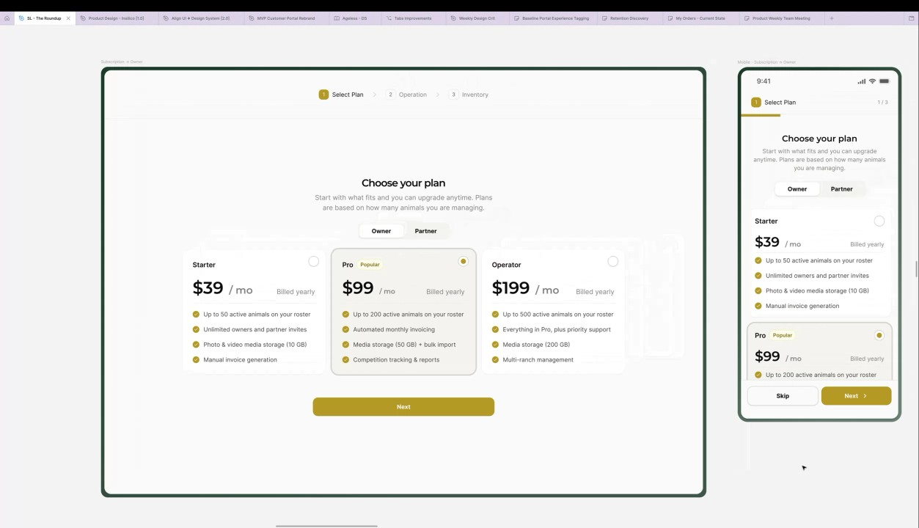
- Profile Setup and Initial User Experience: After selecting a plan, users provide basic profile information such as their first name, ranch, state, and an optional phone number (00:03:04). Following the profile setup, new users will land on a dashboard where a small onboarding tour is being considered to help users navigate features like inventory and ranches, which WyldSol agreed would be helpful, especially if the target group is not tech-savvy (00:04:16). Claudiu Constantin noted that they will not go into detail on the tour until it is confirmed as necessary, but it can be expanded during the development phase (00:05:34).
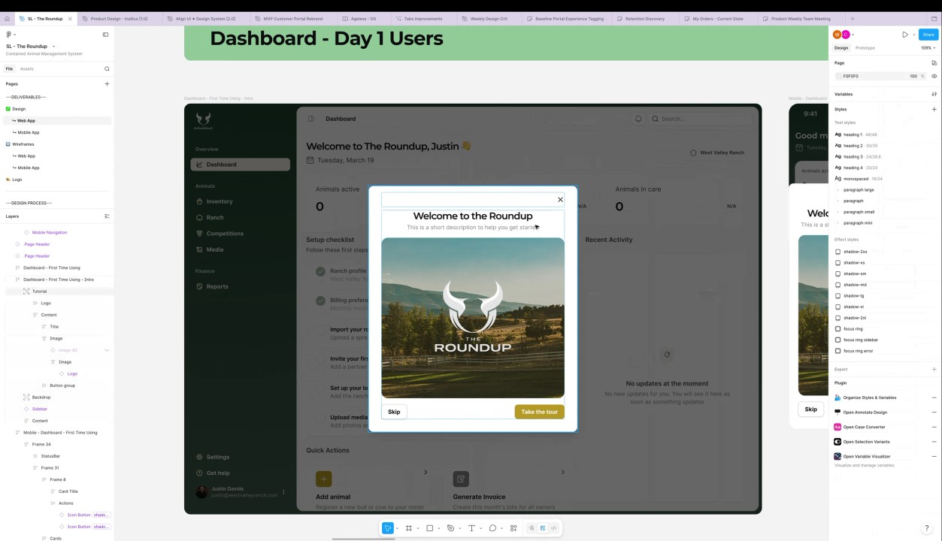
- Dashboard Updates and Design Refinements: The dashboard for the Minimum Viable Product (MVP) excludes invoicing features, and the recent activity section has been updated to match prior comments (00:05:34). The colors for the quick actions were changed from pink and blue to earthy tones, such as green, brown, and yellow, which WyldSol confirmed was better. Claudiu Constantin also added missing notifications and search buttons to the mobile view (00:06:53).
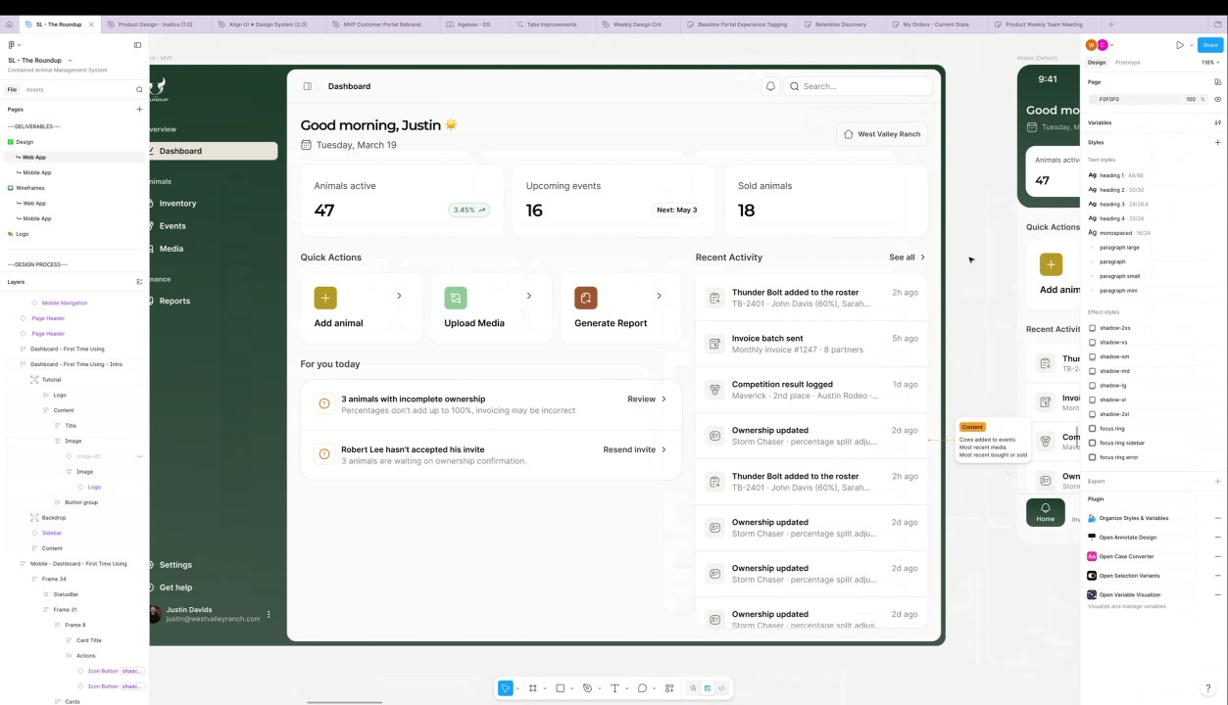
- Inventory Updates and Multi-Select Actions: Feedback on the inventory section was applied, including new icons for filtering and the addition of multi-select options for animals (00:06:53). Examples of bulk actions include updating status, adding to an event, adding a tag, exporting, or marking as inactive, and it was suggested that changing locations could also be a relevant bulk action. WyldSol suggested adding "changing locations" as an action since ranchers would need to select multiple animals to move them to another field (00:08:16).
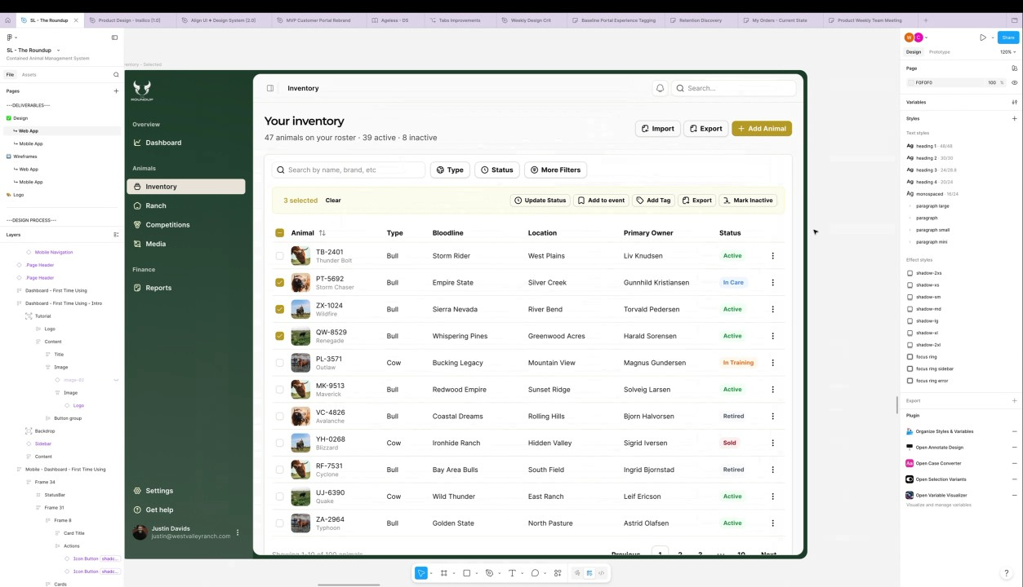
- Event Flow Simplification and Display Options: The event concepts were simplified by merging the event listing and scheduled time into a single aggregated view that summarizes upcoming and past events (00:09:18). For the upcoming events table on mobile, Claudiu Constantin opted for a side-scrolling table but suggested that a future view switch between a card view and a table view could be added post-MVP. It was decided that for the mobile side-scrolling table, the date column should be made sticky so that it always floats on top of other columns (00:10:39).
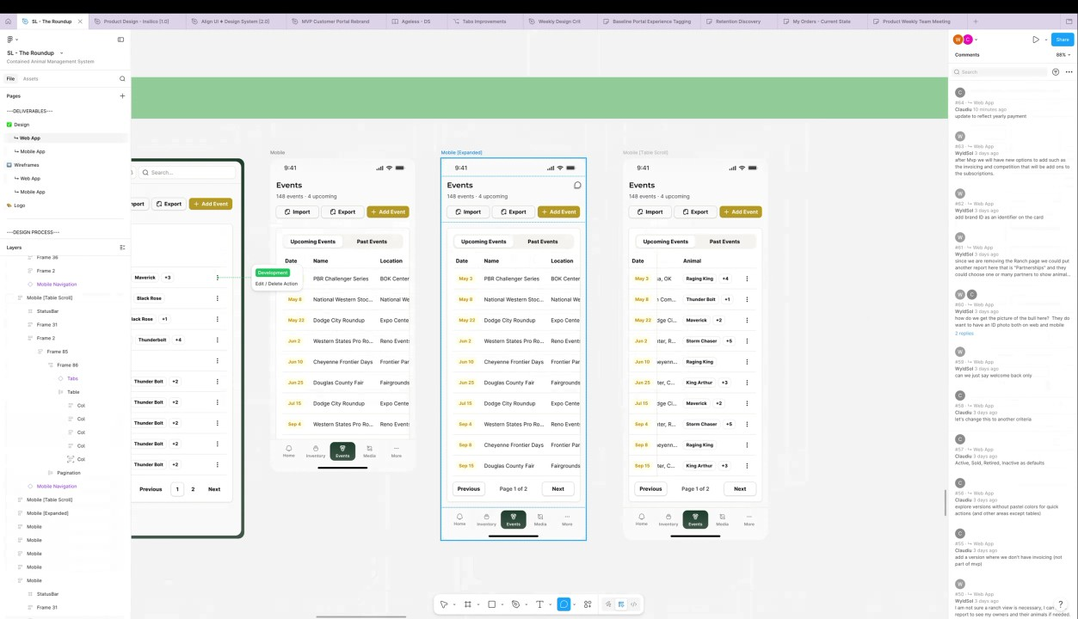
- Event Recaps and API Considerations: For past events, WyldSol suggested users should be able to create recaps, including comments on animals (e.g., performance, injuries) and the event itself (e.g., parking issues) (00:14:38). Claudiu Constantin noted that they will add a comment about considering an event recap post-MVP, which would include mentions about animals and general event comments (00:17:04). Regarding the add event flow, Christian Ruiz suggested that manually adding event information could help shape the structure of the API endpoints if they are built later (00:13:30).
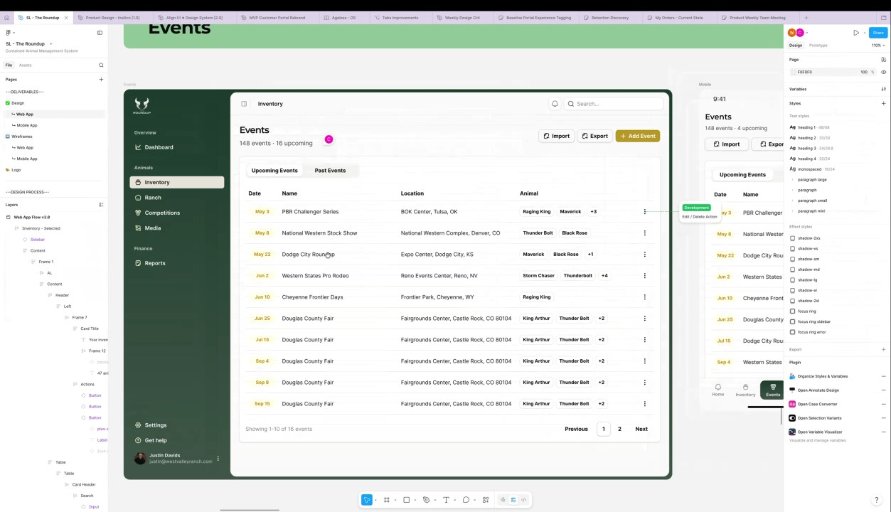
- Settings, Ranch ID, and Partner Management: WyldSol raised the need for a unique Ranch ID to connect partners within the ranch, especially in situations where a person is a partner to multiple ranches (00:19:44). Claudiu Constantin will add a preview of the Ranch ID in the settings area for easier mapping or inviting (00:21:21). When managing partners, Claudiu Constantin noted that bull owners currently have the unique permission of being able to upload media, unlike partners (00:22:32).
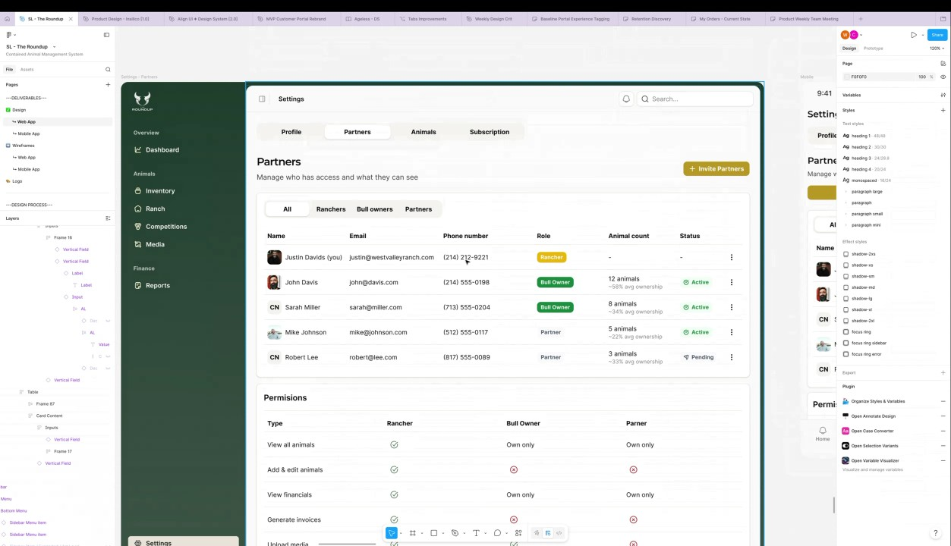
- Role Semantics and Handler Consideration: WyldSol noted that the roles might be driven by percentage ownership and suggested there may not be a significant difference between a "bull owner" and a "partner" (00:22:32). They introduced the role of a "handler," which applies if one person trains a bull sent by the owner, and this information would be useful for competitions. Claudiu Constantin noted they will update the design comment to reflect the potential change from "Bull Owner" to "Handler" to capture this situation (00:23:42).
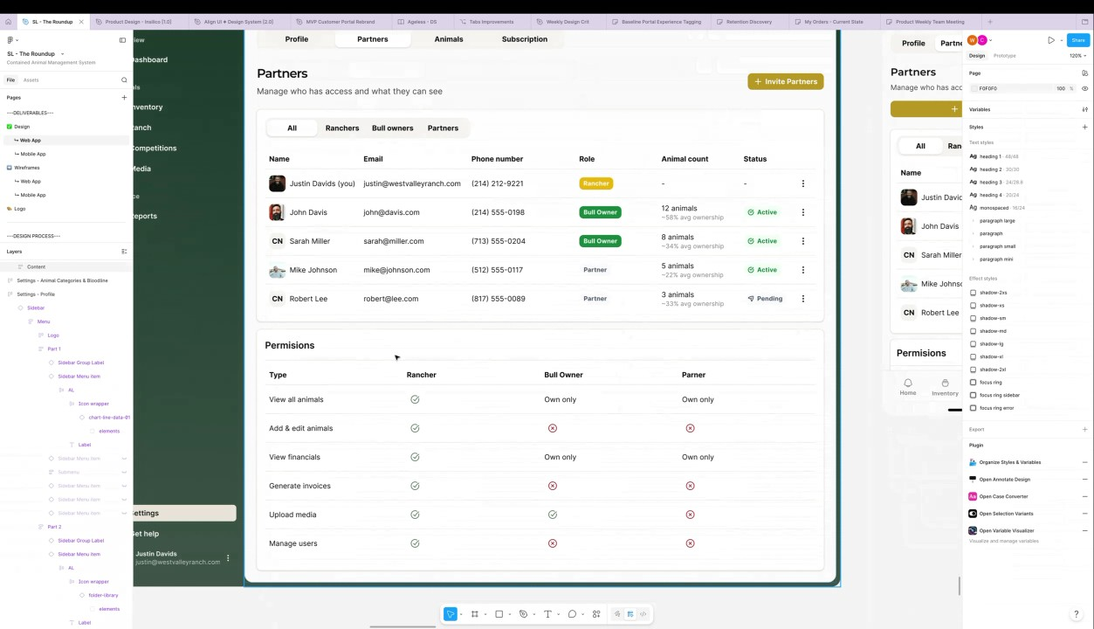
- Animal Customization and Status Constraints: Claudiu Constantin changed their mind about allowing users to remove the basic statuses for animals, deciding that the basic statuses should not be editable to avoid potential technical issues (00:25:02). They decided that the very basic animal types should also not be removed, and WyldSol committed to asking stakeholders about which specific animal types are considered essential (00:26:32).
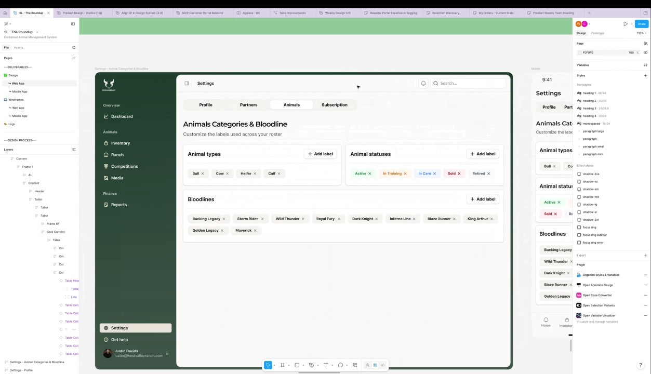
- Subscription View and Upcoming Deliverables: The subscription area displays the current plan, payment details, and renewal information, with a reminder showing features and limits like the number of active animals (00:26:32). Claudiu Constantin noted that the remaining screens—adding an animal, adding media—will be completed by the end of the day on Monday (00:29:08) (00:34:11). Francisco Perez confirmed that this was the last design review meeting and future updates will be async via Basecamp (00:27:48).
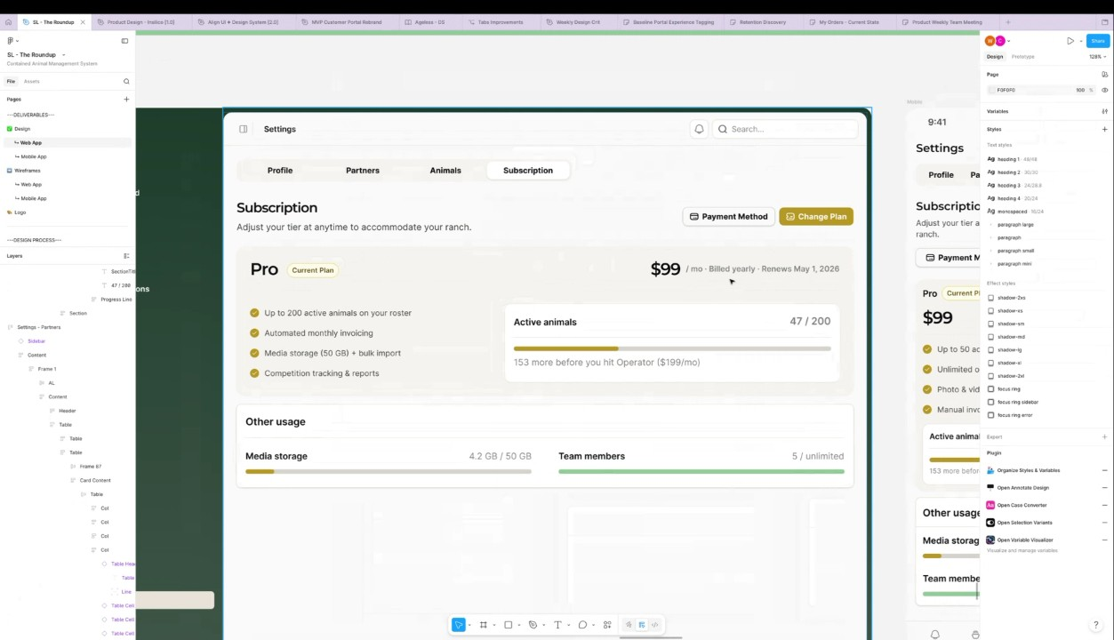
- Media Sharing and Final Review Steps: WyldSol confirmed that users would not need to select who to share media with during the upload process but would likely want to share a collection of media with a specific contact from the media page (00:31:50). Claudiu Constantin will add the ability to share pictures/media to the documentation. WyldSol will review the language used in the designs, and Claudiu Constantin will clear out old comments and remove comparison views, leaving only the final design view (00:33:00).
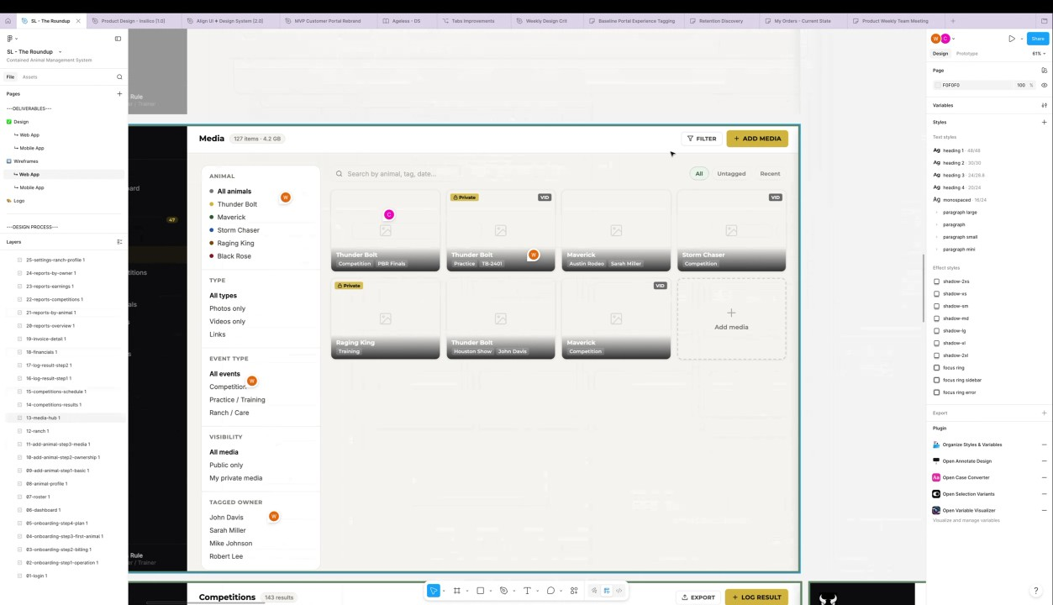

You should review Gemini's notes to make sure they're accurate. Get tips and learn how Gemini takes notes
How is the quality of these specific notes? Take a short survey to let us know your feedback, including how helpful the notes were for your needs.

📖 Transcript
May 7, 2026

Contained Animal Management System | Design Review 3 - Transcript

00:00:00

Francisco Perez: Okay. Uh so yeah, thank you very much. Uh welcome to this third review. So let's take a look at the updates that Cloud has for us today.
Claudiu Constantin: Okay. Yep. One second. Cleaning up some stuff. Um, okay. Let me share my screen. Okay. Uh, I've added a separate section here so I don't remove some of the feedback just so we can keep track of certain things. I'll probably remove them after our last session so that there's a confusion. But for now, let's get going with the newer designs. authentification. Nothing changed here. All the same. But as I mentioned yesterday, the on boarding does change. Uh namely we're starting once they sign up or we will actually let me remove this. Okay. We're going to be showing them the subscription plans that they need to select and it's part of an on boarding flow of three steps. So, it's selection plan, some data about their operation, and then inventory import if they want to.

00:01:26

Claudiu Constantin: If not, they can skip and they can do it afterwards. For the plan, I've added two tabs here at the top where you can switch between owner or partner since we don't really have enough space to properly explain what the each tier plan is. So, that's why I've decided to go with this approach. First we show owners, starter, pro or operator. We also have mobile screens of course for this. Uh one small thing that I just noticed here can't skip. Uh and we have the partner here view here below where we can see we only have one card currently but who knows maybe at some point we can add more. uh they can select it and they press next with the partner subscription of course uh pricing features/details are placeholder for now although true but uh might need the last verification before you actually publish this um all right then when they select a plan of
WyldSol: Yeah.
Claudiu Constantin: course they'll have to put uh payment info. Then they need to pay and once they do so that is done and they will be seeing a success that they have paid that their subscription is active and the welcome what plan they are they are on and how much they pay.

00:03:04

Claudiu Constantin: Uh, one more mention here. Sorry, I did add the pricing as I mentioned and I also mentioned that it's build yearly. So, just to keep in mind that we're showing we're showing the monthly payment, but it's actually build yearly and they can't really change.
WyldSol: Okay.
Claudiu Constantin: And I have to leave a comment for me. I didn't change this one. Update to reflect yearly payment. I left this one with the monthly logic and I need to update one. Um, okay. So once they do that, now they can start setting up their profile. Uh, and on this profile we're asking for, you know, first name, ranch, state, phone, optional. Uh, we also had to mention that they can add ranches and locations later if they want to. Um, and after they set up this basic info, they can import their inventory if they want to. And that's when they go into that complicated uh import flow. And uh, of course, they have an option to skip if they don't want to.

00:04:16

Claudiu Constantin: Um, one more mention for me here. I didn't go back button. Okay. Actually, never mind. This was right. You cannot go back to the payment. Uh, all right. And once they do so, if they decide to do it or not, uh, or if they skip, they will land on a dashboard for day one users, let's call them. But I'm thinking that if time allows, we could maybe also do a small onboarding process for them. That would be pretty nice. Um just to mention a few things like hey you can add this here you can add that there um but nothing too crazy in that sense was a reason for not showing I don't know why okay it shows now and basically when they press start the tour uh we will show them around a few items like hey this is your inventory this is where you can add stuff this is your ranch where you can add various items. This is the media where you can check out your media and reports.

00:05:34

Claudiu Constantin: Just as a quick intro in case we deem that maybe our target group is not
WyldSol: Yeah, I think that would be helpful.
Claudiu Constantin: techsavvy. Yeah. If we deem that it's not asserted,
WyldSol: Yeah.
Claudiu Constantin: then we can simply remove it. That's fine. They can skip, of course, but might be useful as an addition. Um, and once they do this small, uh, I didn't really go into the details, by the way, because I wasn't sure if this this was needed and I had other areas to focus on, but this can be expanded afterwards if in the development phase. Um, once they check that out,
WyldSol: Okay.
Claudiu Constantin: they will have a blank slate, right? So, they will still need to do import their roster, they will need to invite their partners, set up their locations, upload media, and so on. It's basically the stepper that we talked about um mobile views of as well of course and this would be wait before I go into that one this is a dashboard for the MVP where we don't include uh invoicing features so I removed all mentions about invoicing in journal and I've also updated the recent activity to match the comments And I also changed the colors here for the quick actions.

00:06:53

Claudiu Constantin: So no more pink, blue, but I instead went with earthy tones. So green, brown, yellow, things like that.
WyldSol: Yeah, that's
Claudiu Constantin: As you can see here in the post MVP example,
WyldSol: better.
Claudiu Constantin: I left all this one in as well just so we have a reference. And we can see um the invoice mention the generate invoice shortcut and some invoices in doing a recent activity mobile view as well.
WyldSol: Okay.
Claudiu Constantin: And I've added the missing notifications and search buttons here because they weren't added beforehand on mobile. Uh and the next step would be inventory. Okay. So for inventory I did apply some of the feedback if if not all actually. Um so filtering with new icons, images for the animals. Um some of them are repeating but just for review purposes.
WyldSol: Yeah.
Claudiu Constantin: Um and of course the multi select option right here. So let's say they've selected three animals. You can see here three are selected. They can quickly clear if they want to or they can select uh some specific actions.

00:08:16

Claudiu Constantin: I added here some examples of update state status, maybe add to an event, add a tag, maybe export them or maybe mark them as inactive. Um we can update these as we go.
WyldSol: Yeah.
Claudiu Constantin: I think these ones are like the most bulk type of action they can do. But depending on their patterns, maybe it's worth updating these to whatever you feel like their most used actions could be.
WyldSol: Okay.
Claudiu Constantin: But I'm I'm estimating something like this to be honest. I'm not sure what else could be applicable when doing multi selections.
WyldSol: Yeah, I'll think about that.
Claudiu Constantin: Um,
WyldSol: I think you captured them all,
Claudiu Constantin: you know,
WyldSol: but I'll double check.
Claudiu Constantin: yeah, maybe changing locations if that's a thing.
WyldSol: Yeah, that would be a thing.
Claudiu Constantin: Um,
WyldSol: They would round them up and take them to another field to feed.
Claudiu Constantin: okay. So, if that happens, maybe adding a location. Uh, we have enough space anywhere here to add multiple actions. I would not overcrowd it though.

00:09:18

WyldSol: Yeah.
Claudiu Constantin: Chris paralysis is a thing.
WyldSol: Just
Claudiu Constantin: So if we add more then think about removing some or maybe consolidating
WyldSol: Yeah.
Claudiu Constantin: them in some other way. Um,
WyldSol: Yeah.
Claudiu Constantin: all right. I haven't started on the add animal flow uh just because it's very similar to adding media. At least one of the steps from adding an animal is shared with the media and I I've left that for last because um I I need a bit of time to process that. So uh this will be for the next session which I think might be async designwise but uh that's fine. It's only a few screens. Then we have the events and here at the event I applied all your feedback uh simplified the concept a bit and I merged um the listing which was this one or is it events competitions with uh events with the schedule time uh tab actually and now they're just one which show a more aggregated information uh which you can see here like a summary of events, how many are upcoming or you can add an event or import.

00:10:39

Claudiu Constantin: And you can switch between two tabs, upcoming event and past events. And for upcoming events, you can see the date first, name of the event, location, and animals. And if you hover over one of these, you can see the full list. Of course, on mobile, I've opted for uh let me go to the more expanded view for a sidescrolling table just because you can see quite a lot of information at a glance. Technically, we can also build two patterns here. So, maybe we can add a toggle in the future where it allows users to switch between a card view and a table view if that's more comfortable for them. each one to its own. I prefer a table view that I can sides scroll with sticky columns if applicable. Right? So imagine maybe if they sides scroll to the right to see more content like what animals are actually participating in these events. We can at least make the the date column sticky so that it always floats uh on top of other tables.

00:11:46

Claudiu Constantin: Uh let me maybe show an example here because I think that'll be
WyldSol: Yeah.
Claudiu Constantin: useful. Let me bring this up just to showcase what I mean here. and the border to the right. Right. So, something like this. Maybe a small shadow. Yeah. So, having something like this while side scrolling, I think it's nice to keep in mind. This can be whatever you want to be honest. Whatever we deem is necessary to view uh as an event level for now. Date could be fine. Um longer names might not be a good choice and I don't think that's a thing they follow anyway. So probably date is the better choice here.
WyldSol: Yeah.
Claudiu Constantin: Um and of course when they scroll back it will snap into place and that will um in the future post MVP maybe. I'm leaving a comment here. Post MVP consider adding a view switch between words and tables. I'm going to leave it here. Okay.

00:13:30

Claudiu Constantin: And the only option you can actually have on the table view here is edit or delete. Um, and maybe edit animals, of course, but that's part of the edit process. So,
WyldSol: Yeah.
Claudiu Constantin: that's that. Um, I might need just a bit. I'm not sure if I will have time to actually add the ad event flow, but it could be useful to know if ultimately we can grab the information automatically from an API because I know you shared a link to an event platform.
WyldSol: Yeah, they don't have an
Claudiu Constantin: Okay, then maybe we can add them manually uh to some
WyldSol: API.
Claudiu Constantin: extent with this information, right? at least name, date, location, and then you can add your animals. And then you manually
Christian Ruiz: Actually, actually that could help shape if at some point you want to build the
Claudiu Constantin: update.
Christian Ruiz: API yourself, that could help shape how are going to be the end points structure based on the designs kind of thing.
Claudiu Constantin: Okay. Yeah, that could also work.

00:14:38

Claudiu Constantin: Uh, it's it's mostly this data basically, nothing else. So, um
WyldSol: Yeah, super simple date, name, and location.
Claudiu Constantin: yeah.
WyldSol: I'm going to post it at the beginning of the
Claudiu Constantin: Yeah.
WyldSol: year.
Claudiu Constantin: Actually, I have one more question here. Um I'm not sure if applicable for MVP, but maybe post MVP. Is there any action they can take after an event has ended for reference purposes?
WyldSol: Well,
Claudiu Constantin: I'm not sure if I asked that this
WyldSol: I thought about that. Yeah, I thought about that, too. And it um I think more like
Claudiu Constantin: question.
WyldSol: um they would do a recap like, hey, this bull didn't do good or this one broke his leg or you know, just kind of a recap on the event or parking was crappy. I need to take a different trailer next time. Just kind of like a for lack of a better word, comments, I guess. But yeah, recaps um until we get the competition piece and then they kind of would have a little bit of that in there.

00:15:52

WyldSol: But I still think they would do a recap on it. And then um one thing I'm curious on this when we hit the edit um and let's say I want to add six more animals, does it pop up? Like what's that flow? If I want to add more animals to
Claudiu Constantin: Uh you can either click on these or edit and then the flow would be uh
WyldSol: this.
Claudiu Constantin: let me show the wireframes because that one isn't done yet. Hello below. All right. Uh, so it's going to be basically a search bar at the top where you can
WyldSol: Okay.
Claudiu Constantin: search for your animals and you can add them in a list. I think that would be like the easiest way to and simplest way to send a message across in that
WyldSol: be searching on the brand
Claudiu Constantin: sense. Uh, yeah,
WyldSol: ID.
Claudiu Constantin: brand ID or name what whatever they want that would be like the key criteria I would say.
WyldSol: So if I type I mean because like a lot of them are named TB.

00:17:04

Claudiu Constantin: Um
WyldSol: Um, so if I started typing TB dash, I'd have the whole list and then I would get and that would go down.
Claudiu Constantin: yeah, I'll have a suggestions. basically have a suggestion and as you complete more and more it will filter from
WyldSol: Okay.
Claudiu Constantin: those suggestions and then you select the animals that you want to add and they will populate the list and when you edit this it's going to be the same list what I did add here as a comment post MVP because it's probably not going to be your part of the solution lab uh event recap with mentions about animals yeah so uh who got hurt who was a weak performer uh and so one and a different section about comments about the event itself as you mentioned bad parking I feel I'm never coming here again type of thing um right and for past events basically the same view uh but with previous events and you cannot really edit anything but you can still see uh the post event recap, right? U in my mind, it's something like once the event is passed, you get here like a banner or some sorts.

00:18:30

Claudiu Constantin: Imagine a rating system right where hey this event has passed you have participated care to give a review
WyldSol: Yeah.
Claudiu Constantin: or want to add any details and that's when they fill out the data and that's when it
WyldSol: Yeah.
Claudiu Constantin: shifts to I mean it automatically shifts to past events but we're going to bring it bring them in front of their eyes as well so that they can at least say yes I want to add data or no thanks and then it just moves the past events with no information
WyldSol: Okay.
Claudiu Constantin: update Um, reports not tackled yet. Uh, what we do have is settings. I've simplified the settings uh with some comments as well and some improvements. Uh, first of all, basic information about the user. So what we already have from the on boarding first name, last name, uh contact email and then we have the ranch details where they can also add multiple ranches if they want to. Um and they will be separated by the same view. Mobile view as well. Um oh by the way on mobile we're access Yeah.

00:19:44

WyldSol: I was going to say on that just so I don't forget Christian it's more for you when we have these partners and like I said I can be a partner of yours and I can be a partner of Claos. Um, I'm wondering if we don't need some kind of ranch ID, something that is very unique to the ranch. Um, that kind of connects the partners at the ranch in the
Christian Ruiz: Yeah, like a like an inter Yeah,
WyldSol: back.
Christian Ruiz: like an intermediate table. So, it's like a many to many relationship.
WyldSol: Yeah. Yeah. Um,
Christian Ruiz: Yeah.
WyldSol: it's one thing I thought of because just how they combine with partners and stuff and when I sell one cuz if I sell one to a ranch that's already in here, I want to be able to say sold to ranch, you know,
Christian Ruiz: Mhm.
WyldSol: ranch ID, whatever,
Christian Ruiz: Yeah.
WyldSol: so it can go there. Okay. Sorry, CL.
Christian Ruiz: Mhm.
WyldSol: Go ahead.
Claudiu Constantin: No problem. Then maybe I'm going to add a preview of the ranch ID here as well between them just just in case maybe it's easier to map them or maybe get an invite.

00:21:21

Claudiu Constantin: Maybe it could be useful to see the ID. Um,
WyldSol: Yeah.
Claudiu Constantin: all right. Then we have partners. This is where they can manage who has access uh and what they can see based on the permissions they have. Uh and they have quick filters between all ranchers, bullowners and partners. Um and here they can see their name of course, email, phone number, their role, how many animals they have in average ownership and account status. For example, I did send an invite but it's still pending. So stuff like that. permissions. Uh, this should be editable because we're we kind of want to let them customize their permissions, I would say, cuz maybe they want to tweak it. But this is a double-edged sword, let's
WyldSol: Yeah. Yeah.
Claudiu Constantin: say.
WyldSol: And Okay, let me think about that a little bit. And so, honestly, I don't know if there and don't take it away now.
Claudiu Constantin: Actually, no.
WyldSol: I need to think about it, but I don't know if there's a difference between bull owner and partner.

00:22:32

WyldSol: I think it is driven off the percentage. And so I don't know if we know that because you could own 70% of it, but it's at my ranch. Um, so I c I kind of like what you have here because it plays well with that situation. So let me think about it. I like this.
Claudiu Constantin: Okay. Okay. Don't the only difference right now is that bull owners can upload media whereas his partners can't.
WyldSol: Let me think about it. Yeah.
Claudiu Constantin: For example, this is just an edge case,
WyldSol: Yeah.
Claudiu Constantin: but uh we could as well change the semantics of the words so that permissions don't necessarily switch between ownership instead to something else maybe like a because ownership is bull owner is more like a
WyldSol: Yeah. Yeah.
Claudiu Constantin: status for the ownership itself and you can derive that from the ownership let's say right Um but yeah,
WyldSol: Yeah.
Claudiu Constantin: this is more like a semantic thing.
WyldSol: I could be the owner and the rancher on the same bowl.
Claudiu Constantin: Yeah. So maybe the permission type is a semantic value which might we could use for something

00:23:42

WyldSol: So
Claudiu Constantin: else.
WyldSol: yeah, let
Claudiu Constantin: Maybe even ranchers,
WyldSol: me
Claudiu Constantin: but rancher is the same. Anyway,
WyldSol: Well,
Claudiu Constantin: uh logic is in place.
WyldSol: and I think we might because there's a different version of them. So if if I sent my ball to your ranch, I would be the owner, but you'd be the handler because you're training them. And so handler is a thing, and I think that plays into here. Um cuz you want to know that.
Claudiu Constantin: Yeah.
WyldSol: I mean,
Claudiu Constantin: Hold on there.
WyldSol: that's a metric that they'll want to know later when we get to the competitions. They'll want to know who the handler was. So that Yeah, I like that. Uh, okay. Let me play with this in my mind. Good
Claudiu Constantin: Okay, I'm going to leave a comment.
WyldSol: job.
Claudiu Constantin: Bull owner might change to handler
WyldSol: Yep.
Claudiu Constantin: just so we don't forget about this uh situation. Um, okay. What we're missing here is the invite flow, which is nothing crazy.

00:25:02

Claudiu Constantin: It's like model with an email at invite flow. Since it's super simple, I think it's worth it adding it here. Um, yeah. Okay. Now, animals. Here is where they can change categories and bloodline and they can customize it as they want basically. Um one actually now that I think about it I will not allow them to remove these basic statuses.
WyldSol: Yeah, cuz those mean
Claudiu Constantin: I changed my I changed my mind because it
WyldSol: something.
Claudiu Constantin: might it might break some tech aspects and we don't want
WyldSol: Yep.
Claudiu Constantin: that. I'm going to leave retired open just as a preview because you can't close it. Actually, no because we have a preview there as well. Okay. So the basic statuses they won't be able to change but they can add more and they can tag accordingly. Um and it's up to them how they want to manage this and then blood lines pretty obvious. Animal types as well uh by default will have these um I guess same question as animal statuses.

00:26:32

Claudiu Constantin: Maybe the very basic ones that are 100% sure should not be allowed to be removed,
WyldSol: Um I would
Claudiu Constantin: but I'm not sure how they they call them. Maybe they have a different name. I
WyldSol: Yeah. Yeah. Because sometimes they call them yearlings,
Claudiu Constantin: don't
WyldSol: sometimes they don't. But yeah, let's hold off on that one. I'll ask the stakeholders.
Claudiu Constantin: Okay, perfect. Then we can leave it as is for these two. But statuses, I think they need to stay like that. Um, and let me update the mobile version as well. While I'm here already, am I missing something? No. Okay. And then we have the subscription area, of course, uh, where they can see their current plan. Uh, they can check their payment and feds, they can change their plan, of course. Um, they can see a reminder here of their features, how many active animals they have. If we don't hit this this uh build yearly, they can see when it reviews renews, sorry.

00:27:48

Claudiu Constantin: Uh, one mention here since they already paid, maybe you want to show the full amount but in a smaller font. I think that's fine. Uh this is a reminder for the next uh plan. If they hit this limit, they will have to upgrade to operator which showcases how much it is per month. Uh and then we have other usage such as media storage and team members which is unlimited for example. We also have a mobile view for this. Uh the only thing we're missing is pay adding a payment method which we already have by the way but just we just need a way to display it here. Show how this right. Okay. And this is as far as I got within these two days. um for our last session which I'm I'm not sure Frank do we still have one more design session that I can go through or is it async
Francisco Perez: I think it should be async uh in regards to review meetings.
Claudiu Constantin: okay okay
Francisco Perez: Yeah, this was the last one.

00:29:08

Francisco Perez: Uh so any updates? Uh let there be a base camp.
Claudiu Constantin: okay because I still have to do adding an animal and adding media
WyldSol: Okay.
Claudiu Constantin: as main flows to this plan, mobile and desktop, of course. Uh, but please let me know if there's anything else that we've missed because I need to check how many hours I have left. Uh, but I think this was part of the main flow.
WyldSol: Hey.
Claudiu Constantin: Uh, we also have reporting. I think reporting was simplified quite a lot to be honest.
WyldSol: Yeah, it was. So, we didn't have
Claudiu Constantin: So we're removing removing placement or map. Okay,
WyldSol: much
Claudiu Constantin: this is the basically the competition by anymore. Yeah, we can reuse a lot of this based on the inventory page. Um settings is done. Charts by event. There's nothing to actually grab from the event except for what they're reporting post event, but we're not going to have that in the MVP phase. Um, so that won't loop in yet

00:30:23

WyldSol: on the animal. Do on the animal profile. Do we have a mockup of the comments?
Claudiu Constantin: here.
WyldSol: I think that would be big for the testing.
Claudiu Constantin: No, no, wait. This is the plan. There was one door. Why is it hidden? I think I have them separately, but uh let me show one more thing. No, we we don't. But I I'll add them to the design anyway,
WyldSol: Okay.
Claudiu Constantin: like a finally design. So, it's part of the flow cuz uh inventory we're missing basically three
WyldSol: Okay.
Claudiu Constantin: steps, which are these ones. Yeah. So this one with some feedback partnership split and the media and then the page itself right so four pages here and adding media is it below we don't have wireframes of wireframes for this but the process is basically the same as this one adding media is basically the same as this single step except for the fact that you also need to tag the animal itself. Uh that's the only extra link

00:31:50

WyldSol: And then just and then if I come from if I come from the media I
Claudiu Constantin: here
WyldSol: don't know what animal it is but I come from the animal it it's pre-tagged right with the X
Claudiu Constantin: of course. Yeah,
WyldSol: that
Claudiu Constantin: exactly. Yeah, you basically have the media section already as part of the animal selection. Whereas if you start from the media uh you have to select an animal as well uh so they can match it with the pictures and add
WyldSol: Yeah.
Claudiu Constantin: tags uh and if it's private or not things like that.
WyldSol: Okay.
Claudiu Constantin: Um actually one extra question here about flexibility. It might complicate things a bit but maybe it's useful. Do we want them to select who to share media with? as in a specific partner maybe and not all partners.
WyldSol: Um,
Claudiu Constantin: Would that be a use
WyldSol: I don't think they would do that here, but they would definitely uh come to the media page and round up some and
Claudiu Constantin: case?
WyldSol: then want to send them to a contact.

00:33:00

Claudiu Constantin: Oh,
WyldSol: They would do that.
Claudiu Constantin: so like a share picture. Okay.
WyldSol: Yep.
Claudiu Constantin: Uh I don't think this has been documented here. So I'm going to add that media should also
WyldSol: Yeah, cuz that's where the contact list comes in.
Claudiu Constantin: yeah okay added uh I'll also take the time to check all these comments so that we don't Um, so that we don't leave any in limbo. I'm just going to make sure that I tackled everything cuz I think I did tackle these ones from the main page. I do need to go one by one and mark them
WyldSol: Okay.
Claudiu Constantin: as
WyldSol: And then um I'll go through and um go over the language. I wrote that down today. Review the language on those.
Claudiu Constantin: Yeah. Yeah. Please do. Uh, I'll share this link again. I actually I don't need to share it.
WyldSol: I'm in there.
Claudiu Constantin: You already have it. Yeah.
WyldSol: Yeah,
Claudiu Constantin: So,
WyldSol: I'm in
Claudiu Constantin: I kept these ones just for comparisons,

00:34:11

WyldSol: there.
Claudiu Constantin: but I'm going to remove them once I clear out these comments, and I'm only going to leave this final view.
WyldSol: Okay.
Claudiu Constantin: Um,
WyldSol: Okay.
Claudiu Constantin: and there's also prototyping. Uh one key thing about prototyping since we don't really have pools close of everything uh the mapping will be with what we have kind of so some actions maybe might not make 100% sense um for example we cannot save states right because we cannot save information per se
WyldSol: Yeah.
Claudiu Constantin: um in some situ ations. Maybe we already have a field state so we don't have an in between screen with filling out the state, you know. So just small things like that.
WyldSol: Okay.
Claudiu Constantin: Okay, that would be it. Uh, and as a delivery time, I would say Monday, end of day for me. So probably morning for you or the rest of the
Francisco Perez: All
WyldSol: Okay.
Francisco Perez: right.
Claudiu Constantin: screens.
Francisco Perez: Yep. And if you have any updates,
WyldSol: Okay.
Francisco Perez: uh, feel free to share them, Claudia, so we can also send, uh, Brandy earlier.
WyldSol: Yep.
Francisco Perez: Okay. All right. Uh well, thank you very much uh for the time. I think it was a pretty good update and uh let's keep in touch regarding any feedback. Uh feel free to continue commenting on the file and also letting Claudia know of anything that needs to be addressed in the in the design. And uh I think Tyler is also going to be contacting you later for meeting with to see the
WyldSol: Okay.
Francisco Perez: final deliverables, right? Yep.
WyldSol: Okay.
Francisco Perez: Okay.
WyldSol: Sounds

Transcription ended after 00:36:13

This editable transcript was computer generated and might contain errors. People can also change the text after it was created.

